PRACTICAL-8

Perform Statistical Parsing using PCFG in nltk

Statistical Parsing
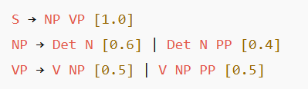
Meaning:
Statistical (probabilistic) parsing uses probabilities to find the most likely parse tree for a sentence using a Probabilistic Context-Free Grammar (PCFG).
Each grammar rule has a probability, and the total probability of a parse tree is the product of rule probabilities. Example:
The parser selects the tree with the highest probability for a sentence.
Parse Tree (Viterbi Parser) – Viterbi Parser is a statistical parser that finds the most probable parse tree using dynamic programming.
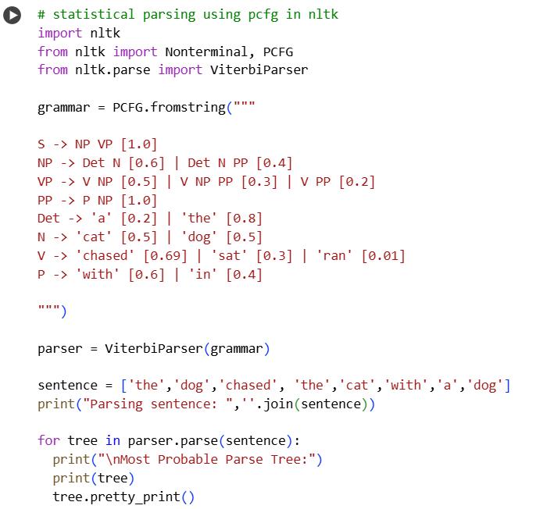
Code:
Output:

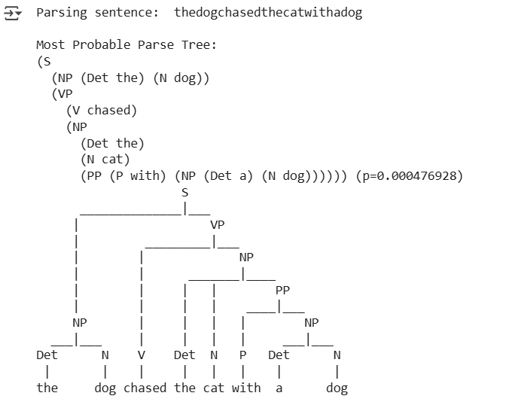
InsideChart Parser
- Computes the total probability of all possible parses for a sentence (not just the best one).
- Used to estimate how likely a sentence is under a grammar.
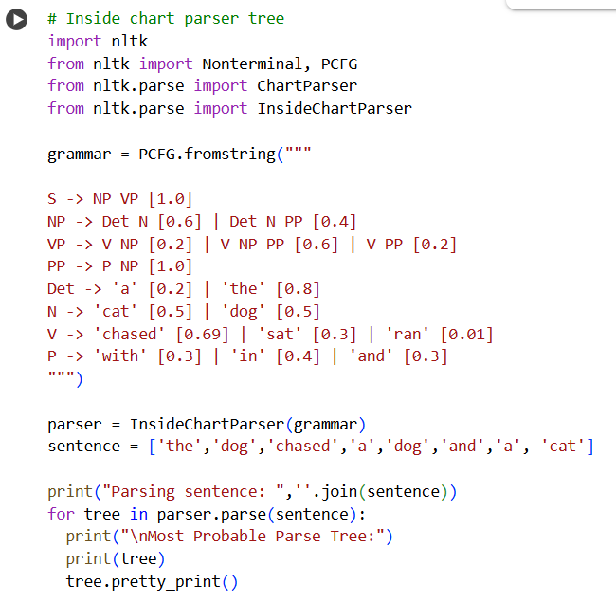
- Useful in training and probabilistic evaluation.
Output:
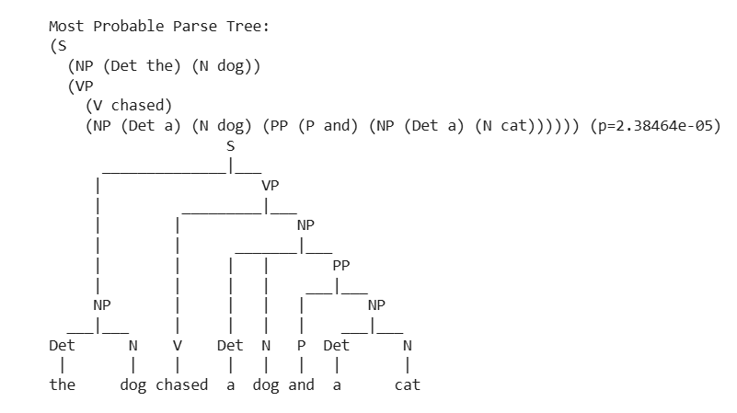
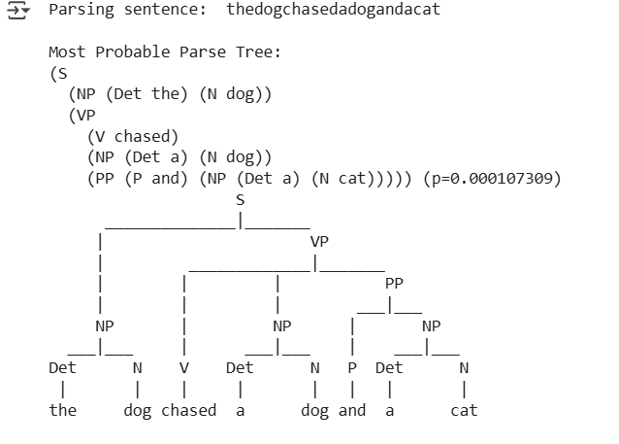

Feature Structures
Represent information as attribute–value pairs.
They allow unification (merging) if features match.

Unification Grammar
- Adds linguistic features like number, person, or tense to grammar rules.
- Ensures agreement (e.g., “He runs” vs “He run” ).
- Uses feature structures to store and check these properties.

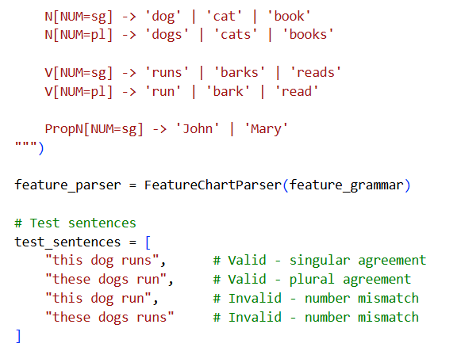
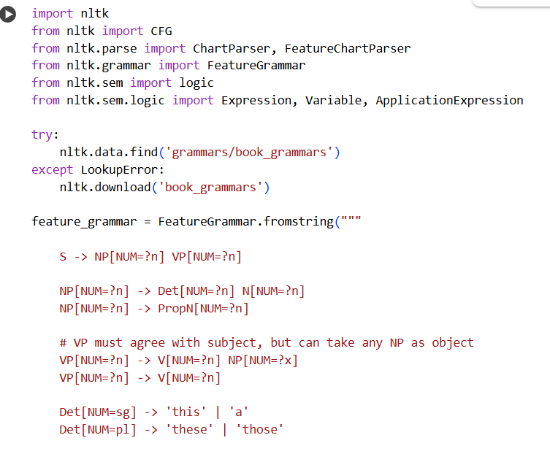
Code:

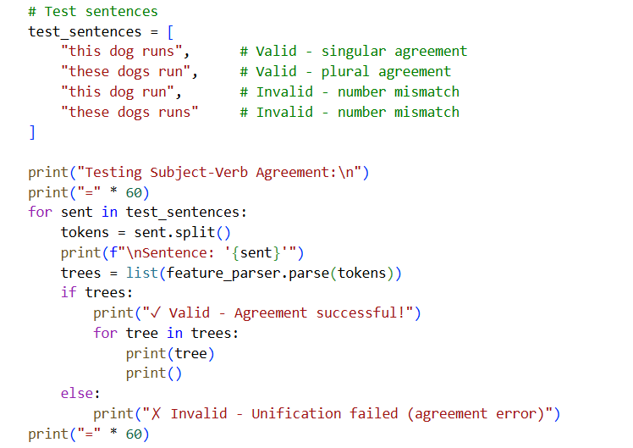

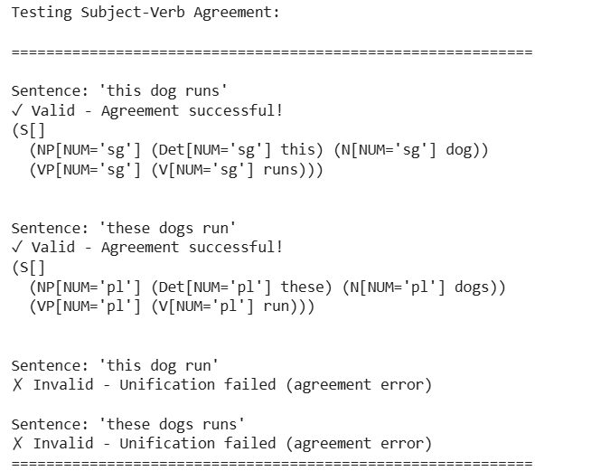
Output:

